
TOBB ETU
Economy & Technology University
BIL 495 / YAP 495

Software Requirements Specification (SRS)
Reference: IEEE 830-1998 / ISO/IEC/IEEE 29148:2018

Document Control Table
Document Title | Project Closure Report
Document ID | SRS
Prepared By (Author) | FinalStack
Reviewed By | FinalStack
Approved By
Preparation Date | 09.11.2025
Approval Date
Version / Revision | 1.2
Confidentiality Level | Internal / Restricted / Public
Reference Standards | IEEE 15288, IEEE 12207, INCOSE SE Handbook v5

Change Record (Revision History Table)
Revision | Date | Prepared By | Reviewed/Approved By | Description of Change
1.0 | 31.10.2025 | FinalStack | FinalStack | Initial Release
1.2 | 09.11.2025 | FinalStack |  | Minor editorial updates and additional content added

1. Introduction
1.1 Purpose
1.2 Scope
1.3 Definitions, Acronyms, Abbreviations
1.4 References
1.5 Overview
2. Overall Description
2.1 Product Perspective
2.2 Product Functions
2.3 User Characteristics
2.4 Constraints
2.5 Assumptions and Dependencies
3. Specific Requirements
3.1 Functional Requirements
3.2 External Interface Requirements
3.3 Performance Requirements
3.4 Design Constraints
3.5 Software System Attributes
3.6 Other Requirements
4. Appendices
4. References

1. Introduction

1.1 Purpose
The purpose of the System Requirements Specification (SRS) document is to define the requirements for the AI-Enhanced Data Preprocessing and Ingestion Layer. This document provides a detailed description of the system’s intended capabilities, interfaces, performance characteristics, and constraints to ensure consistent understanding among all parties involved in the project.

1.2 Scope
The software is named AI-Enhanced Data Preprocessing and Ingestion Layer. It shall take real time sensor data from NICU devices and before feeding the data to AI diagnosis modules it will standardize the data according to HL7, Dicom standards and perform quality checks. Store the processed data and feed it into AI diagnosis tools while ensuring full compliance with GDPR and the protection of patients’ health and personal information.

1.3 Definitions, Acronyms, Abbreviations
- AI: Artificial Intelligence. The intelligence of machines and the branch of computer science that aims to create it.
- NICU: Neonatal Intensive Care Unit. A specialized unit in a hospital for the care of ill or premature newborn infants.
- HL7: Health Level Seven. A set of international standards for transfer of clinical and administrative data between software applications used by various healthcare providers.
- DICOM: Digital Imaging and Communications in Medicine. The international standard to transmit, store, retrieve, print, process, and display medical imaging information.
- GDPR: General Data Protection Regulation. A regulation in EU law on data protection and privacy in the European Union and the European Economic Area.

1.4 References
- HL7: Health Level Seven
- DICOM: Digital Imaging and Communications in Medicine
- GDPR: General Data Protection Regulation
- IEEE 830-1998: IEEE Recommended Practice for Software Requirements Specifications
- ISO/IEC/IEEE 29148:2018: Systems and software engineering — Life cycle processes — Requirements engineering
- IEEE 15288: Standard for Application and Management of the Systems Engineering Process
- IEEE 12207: Standard for Information Technology — Software Life Cycle Processes
- INCOSE SE Handbook v5: INCOSE Systems Engineering Handbook, Version 5
- ISO/IEC 25010:2011: Systems and software engineering — Systems and software Quality Requirements and Evaluation (SQuaRE) — System and software quality models

1.5 Overview
This document is structured to provide a comprehensive Software Requirements Specification (SRS). Following this introductory section, Section 2, "Overall Description," will detail the product's perspective, functions, user characteristics, constraints, assumptions, and dependencies. Section 3, "Specific Requirements," will then elaborate on functional, external interface, performance, design, and software system attributes, including a note on the transition from Non-Functional Requirements to System and Software Quality Attributes. Finally, Section 4 will contain "Appendices" for supporting details, and Section 5 will list "References."

2. Overall Description

2.1 Product Perspective
The system shall operate between multiple NICU devices, Databases and AI Modules. It shall transfer data constantly in real time and shall be constructed to be modular and easy to integrate with these external actors.

2.2 Product Functions
The AI-Enhanced Data Preprocessing and Ingestion Layer will primarily ensure that real-time sensor data from NICU devices is accurately prepared and managed before being used by AI diagnosis modules. Its key functions include:
- Data Standardization: The system shall convert incoming sensor data into standardized formats (HL7, DICOM) to ensure compatibility and consistency across different healthcare systems.
- Quality Control: The system shall perform checks on the data to ensure its accuracy and completeness, preventing faulty or incomplete information from reaching the AI diagnosis modules.
- Secure Storage: The system shall securely store all processed data, adhering to privacy regulations like GDPR to protect patient health and personal information.
- Real-time Diagnosis Display: The system shall facilitate the real-time display of AI diagnoses, ensuring that medical professionals have immediate access to critical insights while maintaining strict patient data privacy.
- Configurable/Modular: The system shall be configurable for NICU devices connections, database integrations AI Module integrations and processing configurations.

2.3 User Characteristics
- Clinic IT: Authenticate user, configure device and database connections.
- AI/Data Engineer: Standardize and process NICU input data. Store data set ready to use in AI research. Store data in a way that is easy to debug. Configure preprocessing settings.
- NICU Clinician: Be able to monitor real time diagnosis from NICU devices.
- Clinic Owner: Wants to system appropriate to regulations.

2.4 Constraints
- Economic / Financial Constraints
Because of its nature as a capstone project, the budget is very limited and therefore the project will prioritize the use of open-source software and scalable cloud infrastructure to minimize costs. Obtaining specialized hardware such as GPUs is restricted so the development of every part of the system will be done on regular CPUs and GPUs that the software team has access to.
The entire development process will be done by a small team of 4 thus the limited budget and human resources may affect the timelines for system integration and extensive testing capabilities.
- Environmental Constraints
Whilst a software by itself does not cause pollution the hardware required to run said software might impact the environment.The system will be developed with open-source software, cloud-based deployment and virtualized testing environments which will prevent negative impact to the environment. Preference will be given to sustainable data centers to minimize carbon footprint.

- Socio-Cultural Constraints
It can be observed that usage of existing medical software can be hard for clinicians and doctors, especially for older individuals. A high level of technological expertise can not be expected from the users of the system therefore the provided interface should be easy to understand and to use.
- Legal, Ethical Constraints
By the nature of the project, it is inevitable to use personal health data of patients. To make sure patients do not suffer from data leaks it is very important to process data according to consent and privacy laws. The system must adhere to healthcare data standards (e.g., HL7, DICOM, FHIR) and comply with medical privacy laws, including HIPAA or regional equivalents. All data handling must prioritize ethical guidelines, informed consent, and secure data storage.
- Manufacturability Constraints
The proposed system, being a software-based digital decision support platform, will focus on scalability, maintainability, and replicability rather than physical manufacturability.
The software will be developed using open standards and well-documented APIs, enabling future updates, interoperability with other healthcare systems.
- Health Constraints
The system will undergo extensive validation to ensure that data preprocessing does not introduce errors that could compromise patient care. The system will be evaluated against real-world hospital datasets under ethical approval.

Supporting Documentation
- Software Constraints:
Universal_SW_Constraint_Tracking_Form.docx
- System Constraints (Real life related Hardware, Legal, or Policy Constraints and other constraints):
Cross-discipline constraint tracking form.docx

2.5 Assumptions and Dependencies
- Data transfer will be done in ethernet with TCP protocol.
- The software user interface will be on a local website.
- The operating system will be Windows 10/11.
- The system will depend on a continuous NICU data stream.

3. Specific Requirements

3.1 Functional Requirements
HL_FR1 The software shall take NICU data and as an output clean, normalize, standardize it.
HL_FR2 The software shall take in real time data streams from NICU devices in HL7-FHIR, DICOM format.
HL_FR3 The software shall store output data as ready to use structured datasets in a given database with given settings for training/feeding AI models.
HL_FR4 The Software shall feed AI models with processed data.
HL_FR5 The Software shall take AI diagnostic engines results and display them
HL_FR6 The software shall store immutable audit logs for data lineage and transformation in the database.
HL_FR7 The software shall store preprocessor settings changes in the database.
HL_FR8 The software shall make login to use itself mandatory.
HL_FR9 The software shall define different usage permissions for different users.
DT_FR1.1 The software shall store all cleaned and standardized data in a database with a predetermined database schema to enforce consistency before committing any records.
DT_FR1.2 The software shall perform automated validation checks such as missing value detection, outlier identification, and data type verification before standardization.
DT_FR1.3The software shall implement configurable fallback actions (e.g., skip record, retry ingestion, or route to quarantine storage) in case of unresolvable data errors.
DT_FR1.4 The software shall automatically remove or pseudonymize identifiable patient information before storage or model feeding to maintain GDPR compliance.
DT_FR8.1 The software shall enforce role-based access control (RBAC), with detailed logging of every user action (e.g., data access, configuration changes, downloads).
DT_FR8.2 The software shall integrate patient data consent management, ensuring that only data with valid consent records are used for AI model training or analysis, in accordance with GDPR and hospital data policies.
The software shall automatically compute and store data quality metrics (completeness, accuracy, latency, error rate) and generate periodic reports accessible through the web interface or via scheduled export.
The software shall maintain versioned records of all cleaned and standardized datasets, allowing authorized users to roll back to previous data processing versions in case of configuration errors or model debugging needs.

3.2 External Interface Requirements
The system shall interact with several external interfaces to fulfill its functions:
User Interfaces:
  - Clinic IT: Will interact with a local website interface to authenticate users, configure NICU device connections, and manage database integrations.
  - AI/Data Engineer: Will utilize the local website interface to configure preprocessing settings, monitor data standardization and quality control processes, and manage the storage of structured datasets for AI research and debugging.
  - NICU Clinician: Will access the local website interface to monitor real-time AI diagnoses from NICU devices.
Hardware Interfaces:
  - The system will interface directly with various NICU devices to receive real-time sensor and visual data streams.
  - Data transfer between devices and the backend is assumed to occur over Ethernet using the TCP/IP protocol to ensure reliable delivery and low latency.
  - The platform will also support video input from camera modules for neonatal posture and motion analysis.
  - All processing will be performed on x86-compatible CPU systems equipped with at least 32 GB RAM and 256 GB local storage to ensure stable operation and real-time AI inference performance.
  - All connected devices are expected to communicate through standardized IoMT gateways using HL7/DICOM protocols for interoperability.
  - The communication interface shall maintain sufficient data throughput to handle up to 20 concurrent devices with a maximum input delay of 50 ms per stream.
  - Where applicable, network interfaces will support redundant Ethernet links and auto-recovery mechanisms to maintain 99.5% system uptime and uninterrupted monitoring operations.
Software Interfaces:
  - Databases: The system will interface with designated databases for secure storage of processed data, immutable audit logs for data lineage, and preprocessor settings changes.
  - AI Modules: The system will feed processed data to AI diagnosis modules and receive diagnostic results from them for real-time display.
  - The system will adhere to HL7 and DICOM standards for data standardization and communication with other healthcare software applications.
  - Compliance with GDPR General Data Protection Regulation will be maintained for all data handling and storage to ensure patient data privacy.

3.3 Performance Requirements
- The software shall be capable of scaling to handle simultaneous data streams from multiple NICU devices(up to 20), and feed the AI engine in less than 50ms after data arrive.
- The software shall display AI diagnostic engines results in less than 10ms.
- Database record must be in 5s.
- The platform shall maintain 99.5% uptime, ensuring continuous monitoring and uninterrupted operation in clinical environments.
- The backend shall support at least 500 concurrent data transactions per second without significant performance degradation.
- The web dashboard shall refresh and display updated patient data within 200 ms of backend updates, ensuring real-time visual feedback.
- The system shall maintain CPU usage below 50% and RAM usage below 75% (24 GB) during full-capacity operation to prevent performance throttling.
- The architecture shall support horizontal scaling through containerized deployment (Docker/Kubernetes), enabling dynamic resource allocation under high load.

3.4 Design Constraints
- The system will use PostgreSQL as a database system.
- The frontend and backend programs are TBD.
- Python will serve as the core language for the ML infrastructure.
- Data transfers and transformations will be in HL7/DICOM standards.

3.5 Software Quality Attributes

Quality Factor | Quality Attribute | Quality Constraint | Metric (Name) | Measurement Method | Source Standard
Performance Efficiency | Response Time | System must process and standardize NICU data and feed AI model within 50ms after arrival. | Average Processing Latency | Measure time from the data arrival to AI feed completion over 1000 samples, calculate average. | ISO/IEC 25010, IEEE 1061
Performance Efficiency | Throughput | The backend shall handle at least 500 concurrent data transactions per second without degradation. | Transaction Throughput | Simulate 500 parallel device data streams; record successful transactions per second. | ISO/IEC 25010
Reliability | Availability | System uptime shall not drop below 99.5% annually under normal operation. | System Uptime Ratio | Monitor system availability logs continuously and compute uptime percentage monthly. | ISO/IEC 25010, IEEE 730
Reliability | Fault Tolerance | System shall recover automatically from transient network or device failures within 10 seconds. | Recovery Time | Simulate fault conditions; measure time from failure occurrence to service restoration. | ISO/IEC 25010
Reliability | Data Integrity | All data collected from NICU sensors shall remain accurate and uncorrupted during storage and transmission. | Data Integrity Rate | Compare sensor input vs. stored data; calculate % of data transmitted/stored correctly. | ISO/IEC 25012
Security | Access Control | Only authenticated and authorized users may access system functions. | Unauthorized Access Incidents | Attempt role-based access violation tests; count number of successful unauthorized accesses. | ISO/IEC 27001, GDPR, ISO/IEC 25010
Security | Data Protection (GDPR Compliance) | All identifiable patient data must be pseudonymized or removed before storage or AI feeding. | PII Leakage Rate | Run automated data scans to detect identifiable patient attributes post-processing. | GDPR (EU 2016/679), ISO/IEC 27018
Usability | Learnability | New users (clinicians, data engineers) shall achieve basic operation proficiency within 2 hours of training | Time to Proficiency | Conduct user onboarding tests; average time to perform predefined basic tasks. | ISO 9241-210, ISO/IEC 25010
Auditability | Data Lineage & Traceability | All transformations and access events shall be logged immutably for audit purposes. | Log Integrity Verification | Review audit log entries; verify immutability and completeness using checksum validation | ISO/IEC 25010
Compatibility | Interoperability | System shall exchange data seamlessly with NICU devices and AI modules using HL7 and DICOM standards. | Interoperability Compliance Rate | Test data exchange with all target systems; % of successful exchanges following HL7/DICOM. | HL7, DICOM, ISO/IEC 25010
Portability | Adaptability, Installability | The system shall deploy on new NICU hardware environments within 1 hour and operate without critical errors. | Deployment Success Rate | Attempt deployment on 3 distinct environments; % of successful installations without issues. | ISO/IEC 25010
Maintainability | Modularity, Reusability, Modifiability | System components shall be modifiable or replaceable with less than 8 hours of developer effort per module. | Mean Modification Time | Track developer time required to implement changes or fixes per module. | ISO/IEC 25010, IEEE 1219

3.6 Other Requirements

4. Appendices
- Requirements and ID’s can be found on : Requirements
- User Case Diagram
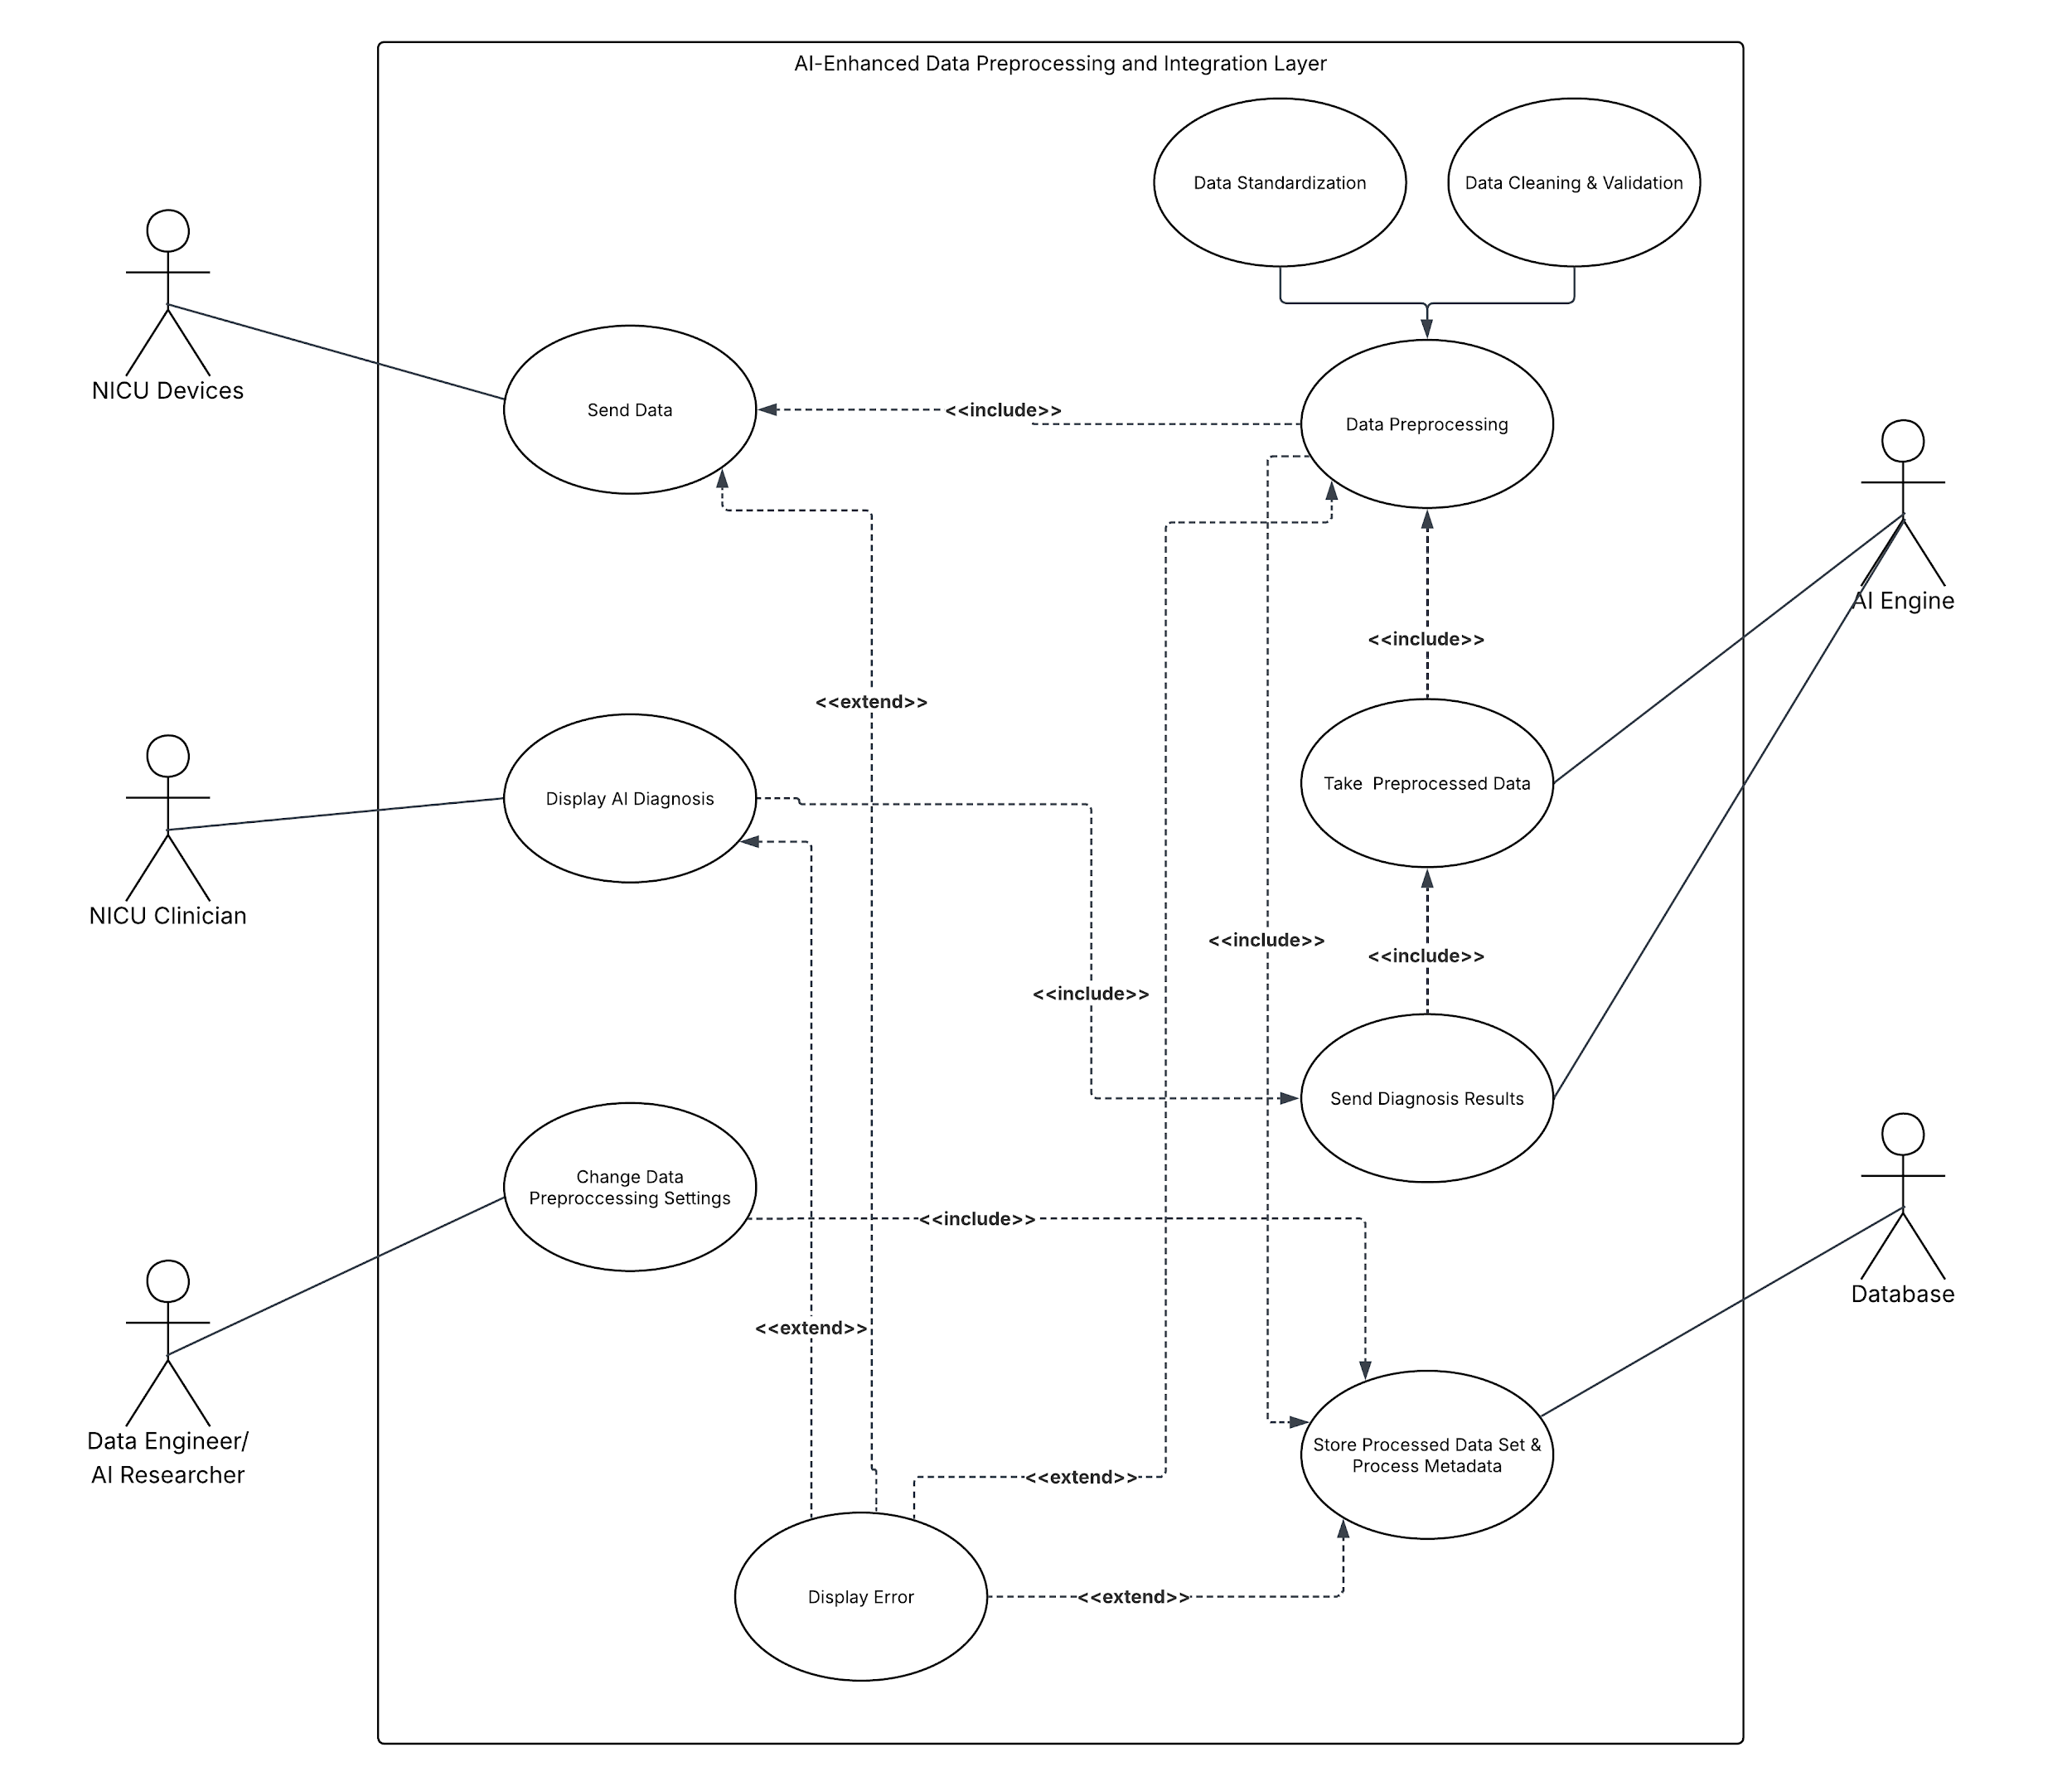
- Context Diagram
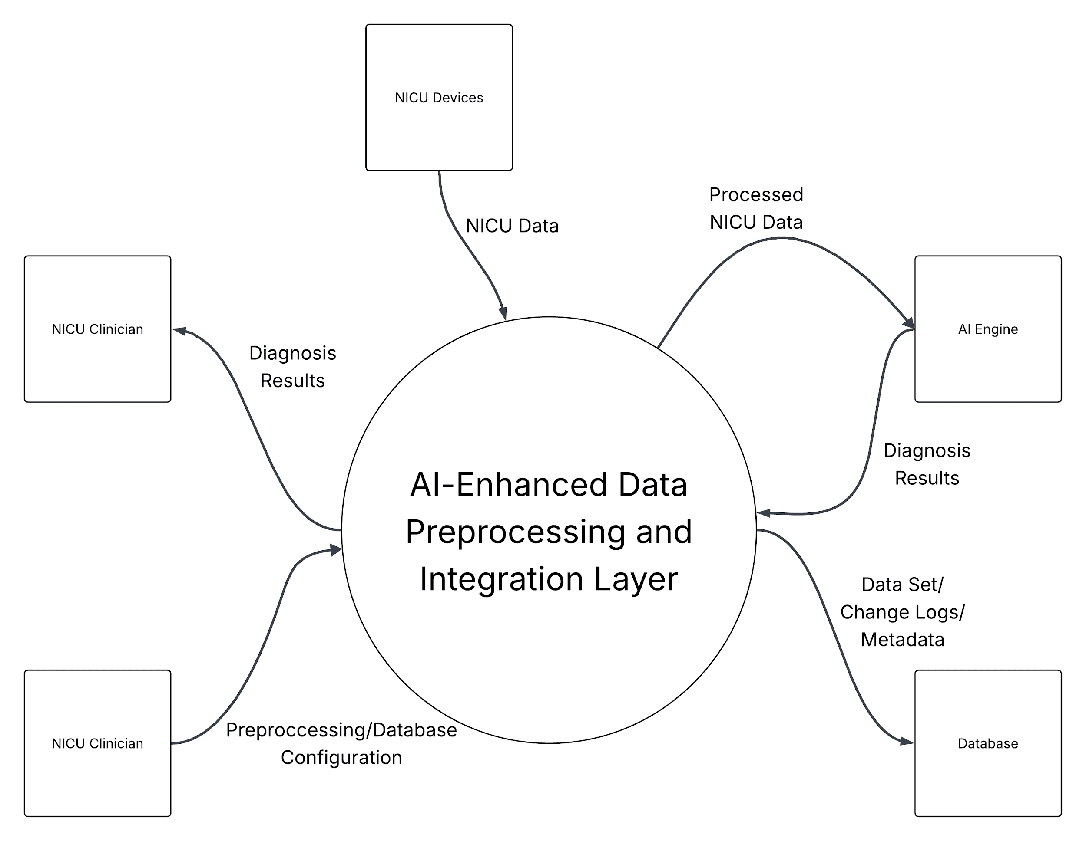
- Activity Diagram
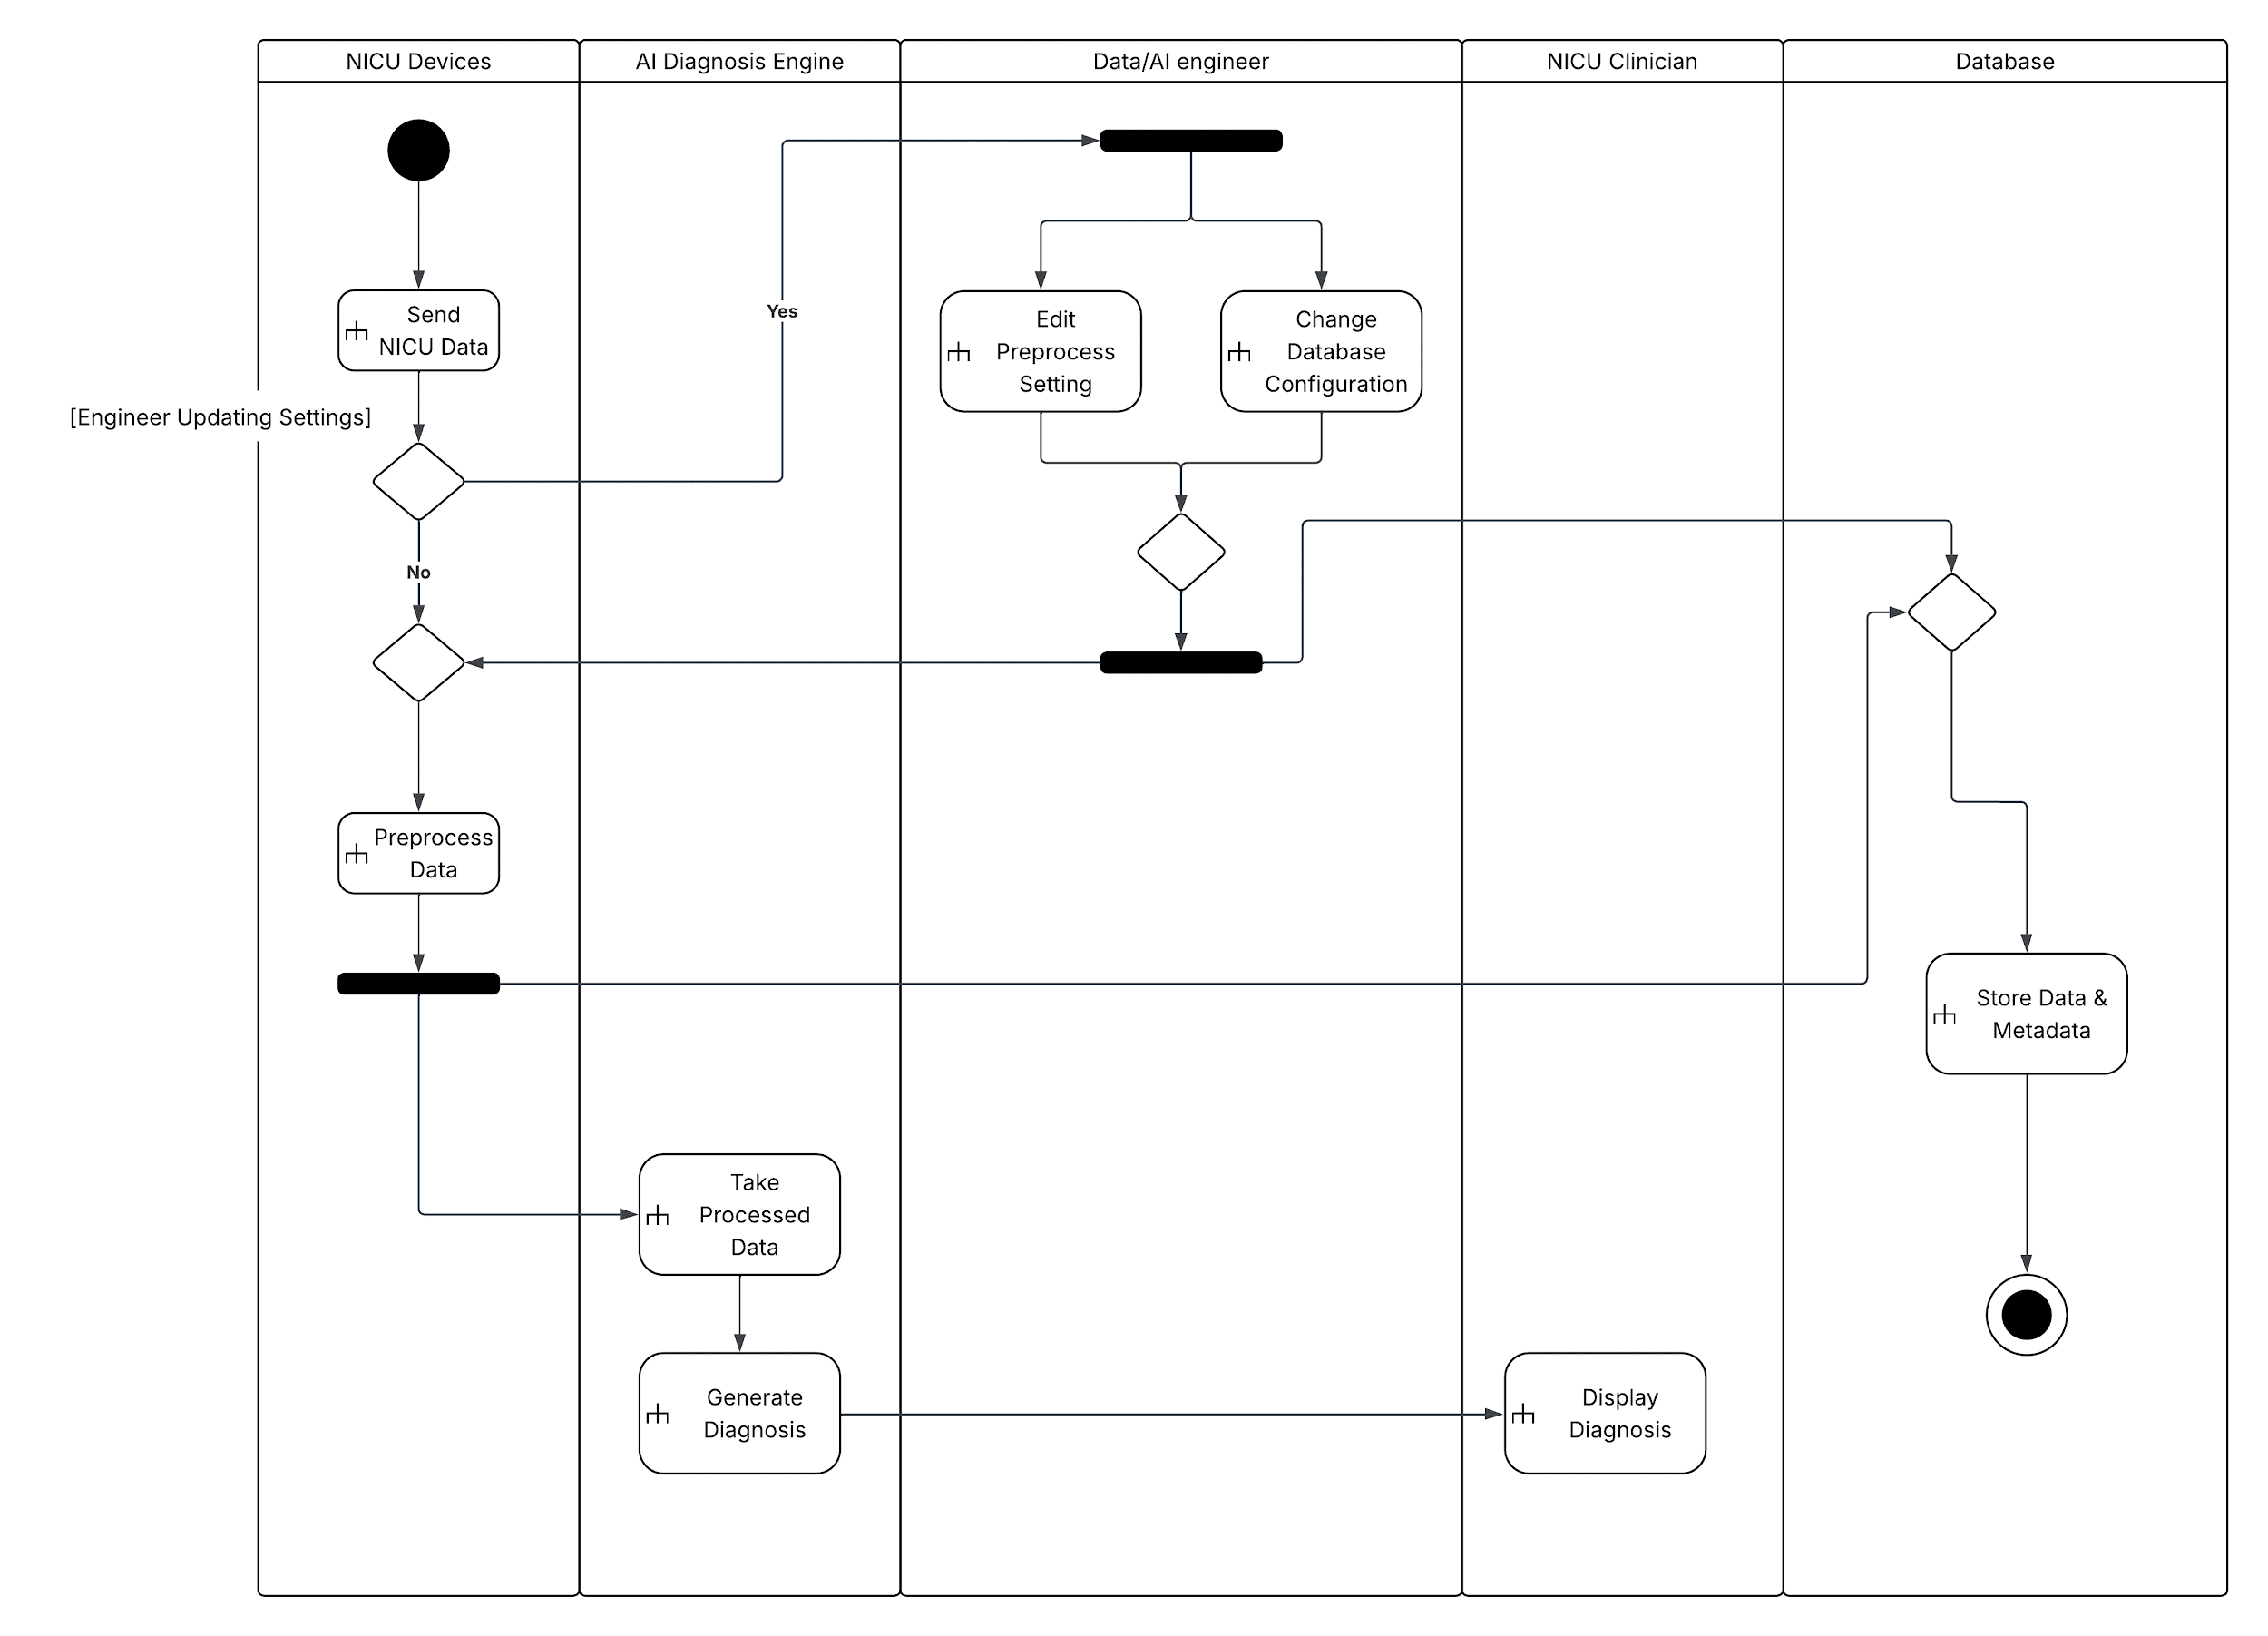

5. References
- IEEE 830-1998
- ISO/IEC/IEEE 29148:2018
- ISO/IEC 25010:2011
- IEEE 15288
- IEEE 12207
- INCOSE SE Handbook v5
- HL7 (Health Level Seven)
- DICOM (Digital Imaging and Communications in Medicine)
- GDPR (General Data Protection Regulation)

